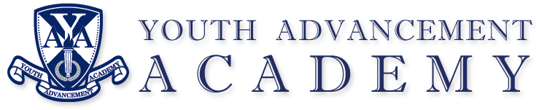

Hello!

We are excited to have your student join Youth Advancement Academy. Before your student can attend our school whether they are in person or remote; students may not start classes until the following are provided:

**Student’s Immunization Record**

**Student’s Birth Certificate**

**Parents’ Driver’s License**

**Proof of Residency for Family** (This can be any bill that comes to your house with parents’ name).

Once these documents and the enrollment packet has been received, your student may start attending classes.

**If these required documents are not provided to Youth Advancement Academy within 48 hours, your student will be dropped.**

Thank you for your help!

Ms. Smith

Director, Youth Advancement Academy

3410 Laird Ave

Kalamazoo 49008

269-443-7745

stacey.smith@youthadvancementacademy.org